|  |  |  |
| --- | --- | --- |
| **S.no** | **Title** | **Pg. No.** |
| **1.** | **Introduction** | **1** |
| 1.1 | Background | 2 |
| 1.2 | Objective | 3 |
| **1.3** | **Purpose & Scope** | **3** |
| 1.3.1 | Purpose | 3 |
| 1.3.2 | Scope | 3 |
| **2.** | **Survey of technology** | **4-6** |
| **3.** | **Requirement & Analysis** | **7** |
| 3.1 | Problem Definition | 8 |
| 3.2 | Planning & Scheduling | 9-10 |
| **3.3** | Requirement Specification | 11 |
| 3.3.1 | Software | 11 |
| 3.3.2 | Hardware | 11 |
| 3.4 | Preliminary Product Description | 12-16 |
| 3.5 | Conceptual Modules | 17-27 |
| **4.** | **Project Code** |  |
| **4** | **References** | **28-29** |

**Structure**

**Preface**

I am glad to make this project **Project Planner**and now I make this project report. In this project report, I include about my project, objective of project, lists of project activities etc.

                       Doing this project I have a great experience and I get knowledge about Project Planner. These all experience and knowledge I am going to share by my project report.

                    During work on this project I met many technical problems. These technical problems are solved by my Faculty  **Mis ___________,** He is very helpful for me in this project so I am very thankful to her.

**Thanking you.**

**PROJECT REPORT**

**(Project Planner)**

**1.INTRODUCTION**

**1.1 BACKGROUND-**

In the fast changing world, information technology and information management are going to play an important role. We are living in the computer age during past

some year .The computer has gaining popularity. Computer revolution found its way into almost every aspect of human life and living. A computer is admirably suited to handle any information and hence is an information processor that is, it can receive data, perform some basic operations on that data and produces results according to a predetermined program.

This Software is used mainly for Project Planner to the students .

The Project Planner software is so designed as to ease the workload of faculty members. The main feature includes Project Planner and guide allotment to the students.

At present Faculty member maintain their Project Planner work manually. So proper system is required. They need full pledged software to maintain their allotment work . Apart from this regular update on project,students and guide .

**1.2 OBJECTIVE-**

The purpose of this document is to specify requirements and to give guidelines for the development of above said project. In particular it gives guidelines on how to prepare the above said project.

This document is intended to be a practical guide for people who developing this software.

**1.3 PURPOSE AND SCOPE-**

**1.3.1 SCOPE**

As this is generic software it can be used by a wide variety of outlets (Students and Faculties) to automate the process of manually maintaining the records related to the students and their projects.

**2.SURVEY**

Today’s world is computer world because most of work is doing with the help of computer. Dependency on computer is behind the few reasons. We cannot easily manage to store large number of data or information single handle. If we will be need some information or data in urgency then we cannot manage in manually these works are very difficult if we cannot use computer.

As this is generic software it can be used by a wide variety of outlets (Students and Faculties) to automate the process of manually maintaining the records related to the students and their projects.

This software is basically updating the manual faculty work to automated Allotment tool. So that organization can manage their record in efficient and organize them.

* The main objective is to automate non computer environment
* To save manpower.
* It will speed the processing of data and transaction.
* It will provide best security features such as provisions of passwords
* **System Objective:**

Today’s world is computer world because most of work is doing with the help of computer. Dependency on computer is behind the few reasons. We cannot easily manage to store large number of data or information single handle. If we will be need some information or data in urgency then we cannot manage in manually these works are very difficult if we cannot use computer.

* **System Context:-**

This section clearly depicts the environment and boundaries of the Project Planner and the entities with which it interacts. It helps us see how the system fits into the existing scheme of things. What the system will do by itself.

* **Functional Requirement:-**

This Software must request Username and Password for access to data, only after authentication will allow access to the system. The Software must allow input of products data from administrator and secured access.

* **Non-Functional Requirement:-**

In this Software Input error will be returned in red with appropriate message box. System should automatically update after every transaction.

**3.REQUIREMENT AND ANALYSIS**

**3.1 PROBLEM DEFINATION-**

Problem introduction or problem starting is the starting point of the software development activity. The objective of this statement is to answer: Exactly *what must the system do*? The software project is initiated by the client’s need. In the beginning, these needs are on the minds of various people in the client’s organization. The analyst has to identify the requirements by talking to the people and understanding to their needs. It goes without saying that an accurate and through understanding of software requirement are essentials to the success of software development effort. All further development like system analysis. System design and coding will depends on how accurate and well understood the requirements are poorly analyzed and specified software will disappoint the user and will bring brief to the developer. No matter how well designed and well appearances are often deceiving. Chances of misinterpretation are very high, ambiguity is probable and communication gap between customer and developer is bound to bring confusions. Requirements understanding begin with a clear and concise heading stating in sentence the task to be performed. Then requirements are describe in a technical manner precise statement.

**3.2 PLANNING AND SCHEDULING**

**PERT CHART**

A project plan needs to be created to ensure the timely completion of the project. As part of project analysis, we break the project down to a number of stages and use a Gantt chart and PERT chart to describe specific tasks and status.

The Work Breakdown Structure of our proposed system “E-Commerce” is shown below.

|  |  |  |  |  |  |
| --- | --- | --- | --- | --- | --- |
| **ID** |  | **Task Name** | **Duration** | **Start** | **Finish** |
| 1 |  | Project Initiation | 3 days |  |  |
| 2 |  | Draft Project Plan | 4 days |  |  |
| 3 |  | Analysis Phase | 9 days |  |  |
| 4 |  | Plan User Interviews | 2 days |  |  |
| 5 |  | Schedule users Interviews | 3 days |  |  |
| 6 |  | Conducting users Interviews | 3 days |  |  |
| 7 |  | System Design | 15 days |  |  |
| 8 |  | Modules Design | 11 days |  |  | |
| 9 |  | Data Structure Design | 4 days |  |  | |
| 10 |  | User Interface Design | 4 days |  |  | |
| 11 |  | Coding Phase | 7 days |  |  | |
| 12 |  | Testing Phase | 9 days |  |  | |
| 13 |  | Integration Testing | 16 days |  |  | |
| 14 |  | System Level Testing | 5 days |  |  | |
| 15 |  | Implementation | 4 days |  |  | |
| 16 |  | Post-Implementation Review | 2 days |  |  | |

**3.3 REQUIREMENTS SPECIFICATION-**

**3.3.1 Hardware Requirements**

* Pentium IV Processor or Above
* 512 MB RAM or Above
* 40 GB HDD or Above
* Color Monitor
* Keyboard, Mouse

**3.3.2 Software Requirements:-**

* Java/JDK
* NetBeans
* MySQL
* SQL YOG

**3.4 PRELIMINARY PRODUCT DESCRIPTION**

**MODULE DISCRIPTION**

This is web based project to manage the allotment of project and project guides.

It will consist of following modules:-

**Modules Made:-**

* **Registration Module: -** Under this students will register themselves with the following details.
* Name :
* Course
* Roll No :
* Session :
* Year :
* Semester:
* Mobile No :
* E mail :
* **Admin Login Module:-** After login in with credentials the admin will get the following modules:-
* Group Allotment.
* Project Planner.
* Guide Allotment.
* Guide Load.
* Guide Management.
* Add Project.
* Report Generation.
* View/Edit Student Details
* **Group Allotment:-**In group allotment we will input the course type and session.

**Course:** S**ession:**

After submitting, we will get list of all students who are registered and we can make group by selecting the students.

The group will be stored in other table, and the students who have formed group will be marked.

* **Project Planner:-**For the Project Planner of project, students along with their group members come with Project Title and a brief summary attached with it. The project Coordinator will search the project. The result will be the exact title projects and similar title project. This will come to know all projects made earlier with the respective topics by clicking on the search result, we will get the details of the projects.

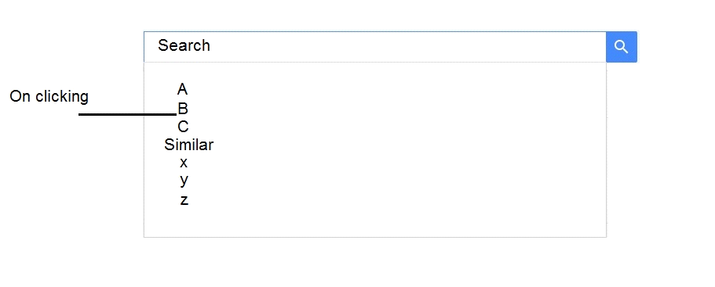

|  |  |  |  |  |  |  |  |  |  |  |  |
| --- | --- | --- | --- | --- | --- | --- | --- | --- | --- | --- | --- |
| **Project ID** | **Project Title** | **Year** | **Category** | **Type** | **H/W or**  **S/W** | **Technology** | | **Branch** | **Owner** | | **Description** |
| **Front-End** | **Back-End** | **Roll No** | **Name** |
|  |  |  |  |  |  |  |  |  |  |  |  |

* **Guide Allotment:-**In guide allotment we will input the **Session**, **Course**, and **Group** of course.
* **Course**
* **Session**

After submitting we will get the list of groups with group members and project title.

Then we will allot a guide to particular group on the basis of expertise in the fields.

**E.g.: -**

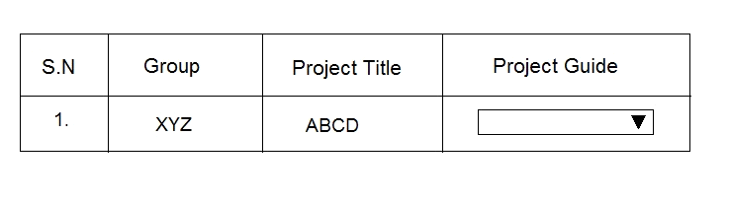

* **Guide Load: -** This will give the information of number of groups under each guide.
* **Guide Management:-**Under guide management we will manage the guide like…
* **Register a Guide**
* **Deleting a Guide**

**Register a Guide: -**Suppose a new teacher is recruited so we will add a guide.

On adding we need the following detail…

* Faculty ID
* Date of Joining
* Name
* Specialization
* Gender
* Contact
* E-mail

**Delete Guide/Update Info: -**This comes when we need to removes guide i.e. when teachers leaves or resign from the post.

* **Add Project: -**This feature is used to enter the details of projects made. Earlier all the information about the project are entered and stored from here.

It consists of…

* Project Title
* Category
* Technology (i)Front End (ii) Back End
* Group ID
* Session
* Group Member Name
* Course
* Brief Description
* **Report Generation: -**Report will be generated in this module:-
* Session Wise Project Report
* Session Wise Guide Report
* Project Name and Their Guide Report
* Search Or Print Project Details
* Guide Wise Report

**3.5 CONCEPTUAL MODEL**

**SYSTEM DEVELOPMENT LIFE CYCLE:-**

The **System development life cycle (SDLC)**, or **Software development process** in [systems engineering](http://en.wikipedia.org/wiki/Systems_engineering), [information systems](http://en.wikipedia.org/wiki/Information_systems) and [software engineering](http://en.wikipedia.org/wiki/Software_engineering), is a process of creating or altering information systems, and the models and [methodologies](http://en.wikipedia.org/wiki/Methodologies) that people use to develop these systems. In software engineering, the SDLC concept underpins many kinds of [software development methodologies](http://en.wikipedia.org/wiki/Software_development_methodologies). These methodologies form the framework for planning and controlling the creation of an information systemthe [software development process](http://en.wikipedia.org/wiki/Software_development_process).

Broadly, following are the different activities to be considered while defining the system development life cycle for the said project:

* Problem Definition
* System Analysis
* Study of existing system
* Drawback of the existing system
* Proposed system
* System Requirement study
* Data flow analysis
* Feasibility study
* System design
* Input Design (Database & Forms)
* Updating
* Query /Report design
* Administration
* Testing
* Implementation
* Maintenance

**1.2 SYSTEM ANALYSIS:-**

**Systems analysis** is the study of sets of [interacting](http://en.wikipedia.org/wiki/Interaction) [entities](http://en.wikipedia.org/wiki/Entity), including computer systems analysis. This field is closely related to [requirements analysis](http://en.wikipedia.org/wiki/Requirement_analysis) or [operations research](http://en.wikipedia.org/wiki/Operations_research). It is also "an explicit formal inquiry carried out to help someone (referred to as the decision maker) identify a better course of action and make a better decision than he might otherwise have made.

System development can generally be thought of having two major components: systems analysis and systems design. In System Analysis more emphasis is given to understanding the details of an existing system or a proposed one and then deciding whether the proposed system is desirable or not and whether the existing system needs improvements. Thus, system analysis is the process of investigating a system, identifying problems, and using the information to recommend improvement to the system.

**1.3 SYSTEM DESIGN:-**

Systems design is the process of defining the architecture, components, modules, interfaces, and [data](http://en.wikipedia.org/wiki/Data) for a [system](http://en.wikipedia.org/wiki/System) to satisfy specified [requirements](http://en.wikipedia.org/wiki/Requirement). One could see it as the application of [systems theory](http://en.wikipedia.org/wiki/Systems_theory) to [product development](http://en.wikipedia.org/wiki/Product_development). There is some overlap with the disciplines of [systems analysis](http://en.wikipedia.org/wiki/Systems_analysis), [systems architecture](http://en.wikipedia.org/wiki/Systems_architecture) and [systems engineering](http://en.wikipedia.org/wiki/Systems_engineering). If the broader topic of [product development](http://en.wikipedia.org/wiki/Product_development) "blends the perspective of marketing, design, and manufacturing into a single approach to product development," then design is the act of taking the marketing information and creating the design of the product to be manufactured. Systems design is therefore the process of defining and developing [systems](http://en.wikipedia.org/wiki/System) to satisfy specified [requirements](http://en.wikipedia.org/wiki/Requirement) of the user. Until the 1990s systems design had a crucial and respected role in the [data processing](http://en.wikipedia.org/wiki/Data_processing) industry. In the 1990s [standardization](http://en.wikipedia.org/wiki/Standardization) of hardware and software resulted in the ability to build [modular](http://en.wikipedia.org/wiki/Modularity_(programming)) systems. The increasing importance of software running on generic platforms has enhanced the discipline of [software engineering](http://en.wikipedia.org/wiki/Software_engineering).

[Object-oriented analysis and design](http://en.wikipedia.org/wiki/Object-oriented_analysis_and_design) methods are becoming the most widely used methods for computer systems design. The [UML](http://en.wikipedia.org/wiki/Unified_Modeling_Language) has become the standard language in object-oriented analysis and design. It is widely used for modeling software systems and is increasingly used for high designing non-software systems and organizations

**ENTITY RELATION DIAGRAMS:-**

The Entity Relation Model or Entity Relation Diagram (ERD) is a data model or diagram for high-level description of conceptual data model, and it provides a graphical notation for representing such data models in the form of entity relationship diagrams. Such models are typically used in the first stage of Management information system design; they are used for example, to describe information needs and/ or the type of information that is to be stored in the Database during the requirement analysis. The data modeling technique, however, can be used to describe any ontology (i.e. an overview and classification of used term and their relationships) for a certain universe of discourse (i.e. area of interest).

In the case of design a Management Information System that is based on a database, the conceptual data model is, a later stage( usually called logical design), mapped to a logical data model such as, relational data model; this is turn in mapped to a physical model during physical design. Note that sometimes, both of the phases are referred a “physical design”. There are number of convention for entity-relation diagrams (ERDs). The classical notation is describe in the remainder of this article, and mainly related to the conceptual modeling. There is a range of notation more typically employed in physical and logical database design.

MANAGES

INVENTORY

ADMIN

DEAL S WITH

COUSTOMERS

BUY

PRODUCTS

MANAGES

**DATA FLOW DIAGRAM**

The data flow diagram shows the flow of data within any system. It is an important tool for designing phase of software engineering. Larry Constantine first developed it. It represents graphical view of flow of data. It’s also known as BUBBLE CHART. The purpose of DFD is major transformation that will become in system design symbols used in DFD. In the DFD, four symbols are used and they are as follows.

* A square defines a source (originator) or destination of system data.

* An arrow identifies data flow-data in motion. It is 2a pipeline through which information flows.

* A circle or a “bubble “(Some people use an oval bubble) represents a process that transfers informing data flows into outgoing data flows.

* An open rectangle is a data store-data at rest, or a temporary

Repository of data.

**Context Level Data :-**

This level shows the overall context of the system and its operating environment and shows the whole system as just one process. Online book store is shown as one process in the context diagram; which is also known as zero level DFD, shown below. The context diagram plays important role in understanding the system and determining the boundaries. The main process can be broken into sub-processes and system can be studied with more detail; this is where 1st level DFD comes into play.

TEACHERS

STUDENTS

Request

ADMIN

Request fulfill

Zero Level Data Flow Diagram

**DATA TABLES AND SCREENSHOT**

**LOGIN FORM-**

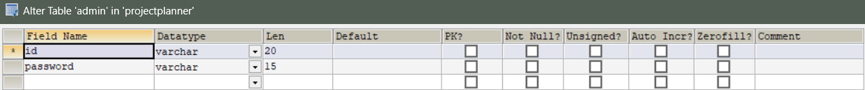

**GROUP-**

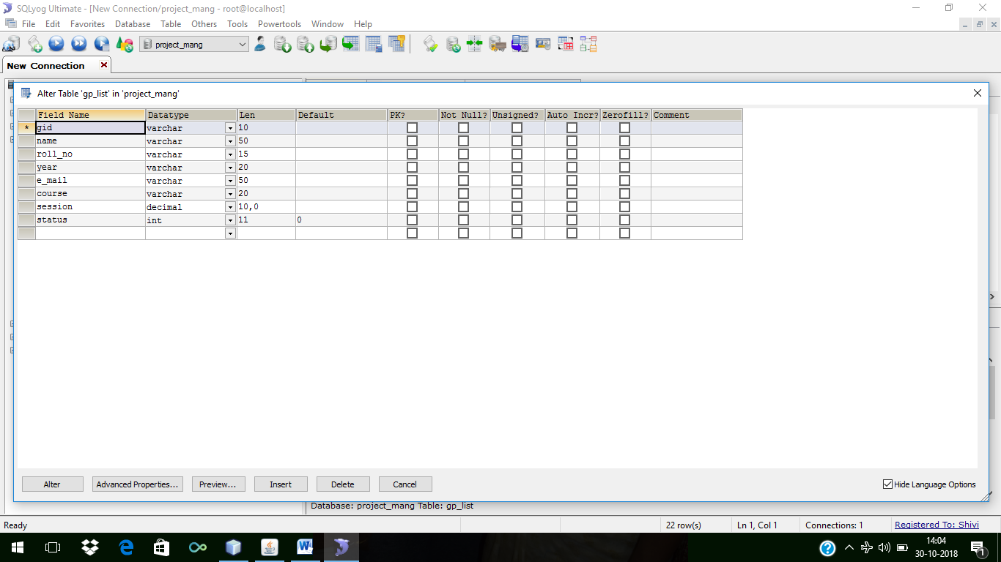

**GUIDE-**

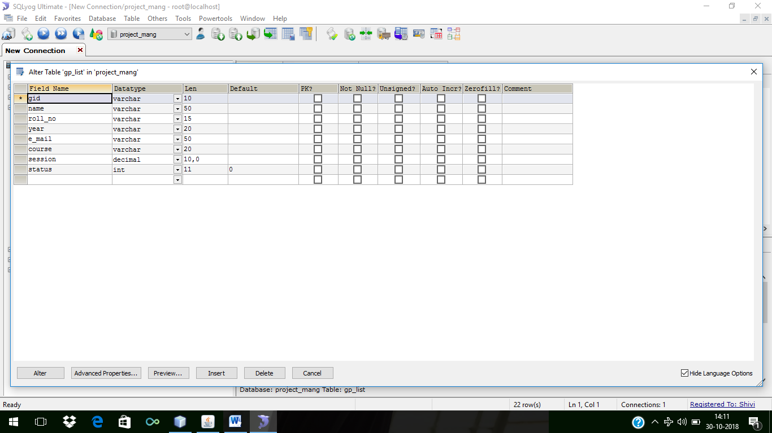

**GUIDE ALLOTMENT-**

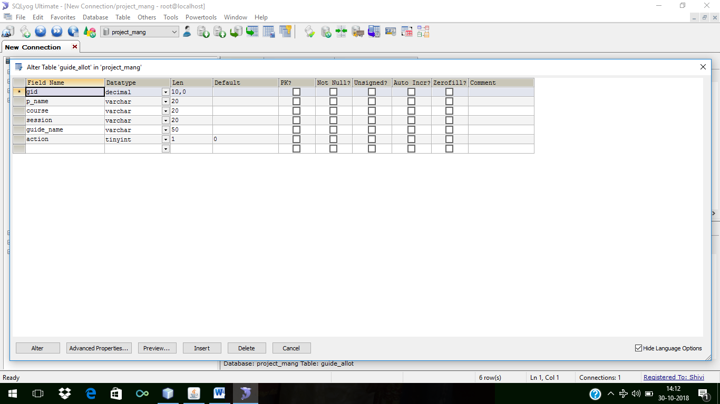

**PROJECT-**

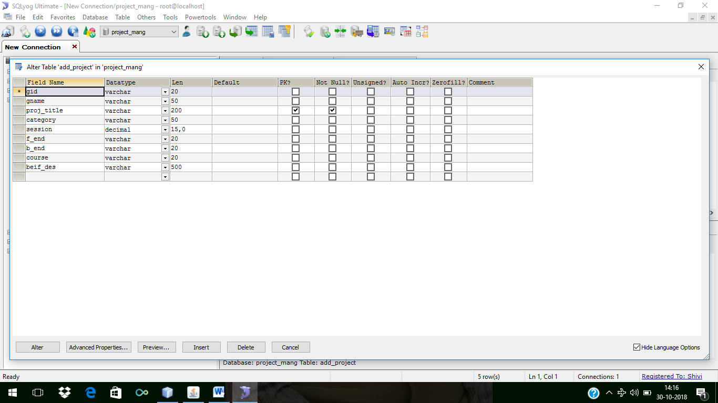

**PROJECT PLANNER-**

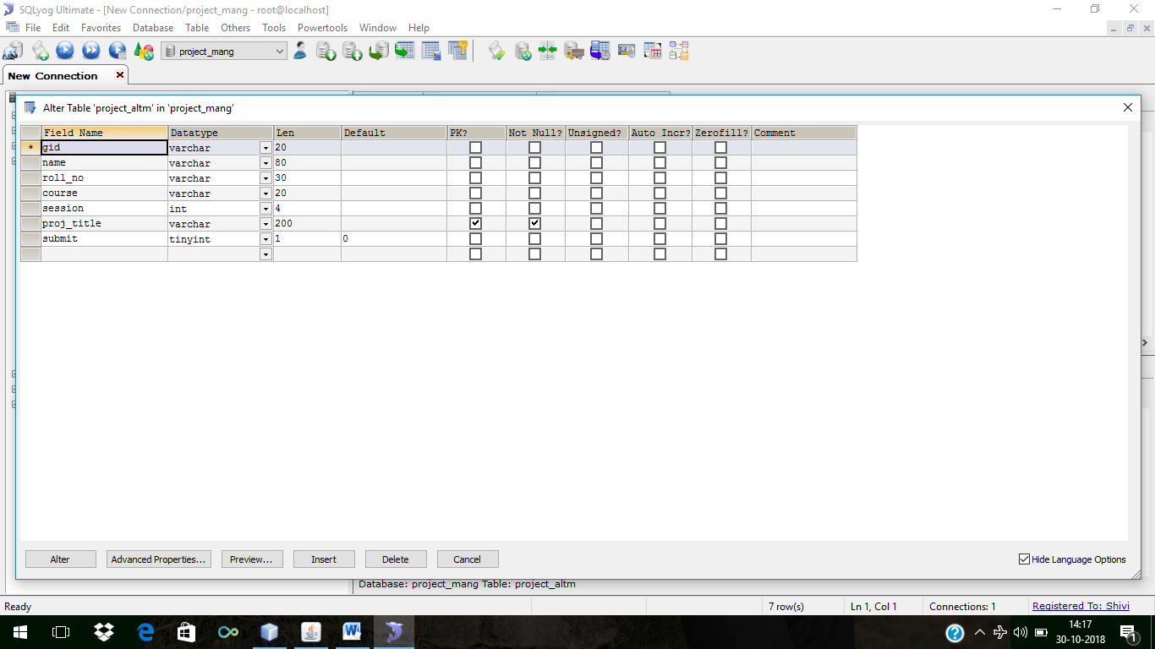

**STUDENT-**

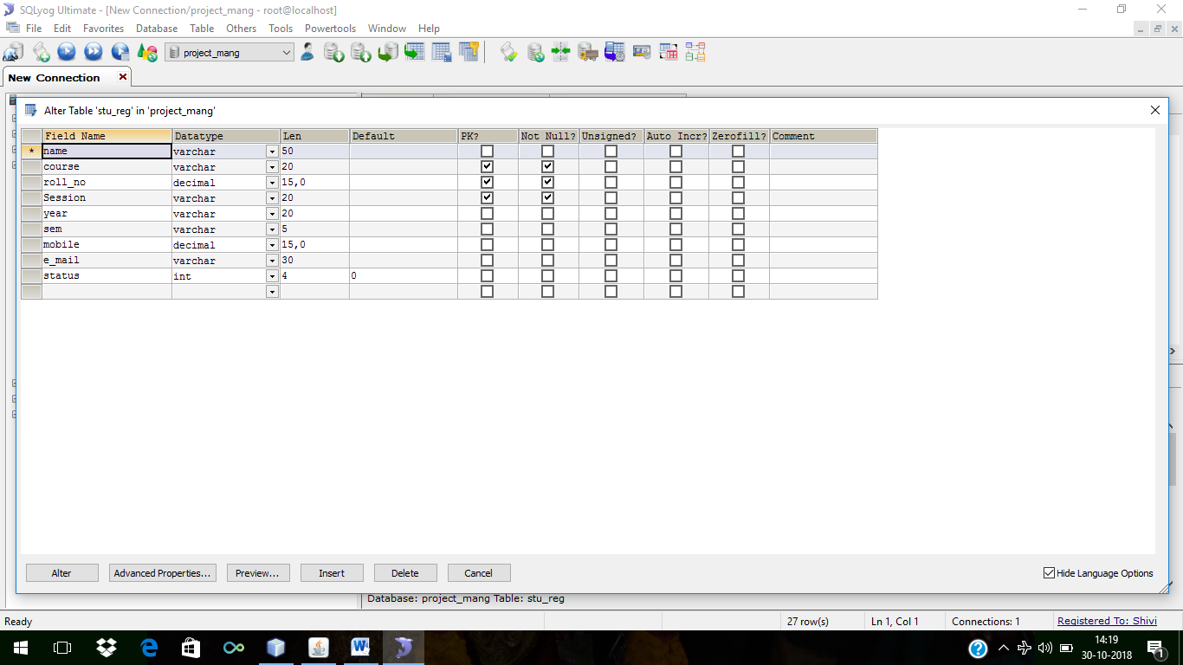

**LOGIN FORM**

|  |  |  |  |
| --- | --- | --- | --- |
| Name Column | Data Type | Constraints | Size |
| User Name | Varchar | **(Primary Key)** | **40** |
| Password | Varchar | Not Null | 40 |

**GROUP:-**

|  |  |  |  |
| --- | --- | --- | --- |
| Name Column | Data Type | Constraints | Size |
| G_id | Varchar | Primary key | 30 |
| Name | Varchar | Not Null | 30 |
| Course | Varchar | Not Null | 30 |
| Roll | Number | Not Null | 5 |
| Session | Date | Not Null | 10 |
| Status | Varchar | Not Null | 30 |

**GUIDE:-**

|  |  |  |  |
| --- | --- | --- | --- |
| Name Column | Data Type | Constraints | Size |
| G_id | Varchar | Primary key | 30 |
| Doj | Date | Not Null | 10 |
| Name | Varchar | Not Null | 30 |
| Speci | Varchar | Not Null | 30 |
| Gen | Varchar | Not Null | 30 |
| Contact | Number | Not Null | 5 |
| Email | Varchar | Not Null | 30 |

**GUIDE ALLOT:-**

|  |  |  |  |
| --- | --- | --- | --- |
| Name Column | Data Type | Constraints | Size |
| Group_id | Varchar(30) | Not Null | 30 |
| Pro_name | Varchar(30) | Not Null | 30 |
| G_name | Varchar(30) | Not Null | 30 |
| Course | Date | Not Null | 10 |
| Session | Date | Not Null | 10 |

**PROJECT:-**

|  |  |  |  |  |
| --- | --- | --- | --- | --- |
| Name Column | Data Type | Constraints | Size |  |
| Title | Varchar | Not Null | 30 |  |
| Cat | Varchar | Not Null | 30 |  |
| Fend | Varchar | Not Null | 30 |  |
| Bend | Date | Not Null | 10 |  |
| G_id | Date | Not Null | 10 |  |
| Session | Date | Not Null | 10 |  |
| Mby | Varchar | Not Null | 30 |  |
| Course | Varchar | Not Null | 30 |  |
| Des | Varchar | Not Null | 30 |  |

**PROJECT ALLOT:-**

|  |  |  |  |
| --- | --- | --- | --- |
| Name Column | Data Type | Constraints | Size |
| G_id | Varchar | Primary key | 30 |
| Pro_name | Varchar | Not Null | 30 |
| Pro_cat | Varchar | Not Null | 30 |
| Course | Varchar | Not Null | 30 |
| Session | Date | Not Null | 10 |
| Status | Varchar | Not Null | 30 |

**STUDENT:-**

|  |  |  |  |
| --- | --- | --- | --- |
| Name Column | Data Type | Constraints | Size |
| Srno | Varchar | Not Null | 30 |
| Name | Varchar | Not Null | 30 |
| Course | Varchar | Not Null | 30 |
| Roll | Number | Not Null | 20 |
| Session | Date | Not Null | 10 |
| Year | Date | Not Null | 10 |
| Semester | Varchar | Not Null | 30 |
| Cont | Varchar | Not Null | 30 |
| Email | Varchar | Not Null | 30 |
| ` Status | Varchar | Not Null | 30 |

REFRENCES-

Reference Books :-

* Herbert Schildt, JAVA2 COPLETE REFERENCE, 5TH edition, Pregti publication, April 2004
* Pankaj Sharma, INTRODUCTION TO WEB TECHNOLOGY, 2nd edition S.K. Kataria & Sons publication, April 2007
* Roger S. Pressman, SOFTWARE ENGINEERING, 3rd edition by McGraw Hill International, April 2002

Reference websites:-

* [www.javaskyline.com](http://www.javaskyline.com)
* [www.apl.jhu.edu](http://www.apl.jhu.edu)

**4.PROJECT CODE**

LOGIN CODE-

new Adminlogin().setVisible(true);

Adminpage.setVisible(true);

setVisible(false);

ADMINLOGIN CODE-

try{

String user=jTextField1.getText();

//System.out.println("ankit");

String password=jPasswordField1.getText();

DBConnection db=new DBConnection();

db.pstmt=db.con.prepareStatement("select * from Admin where id=? and password=?");

db.pstmt.setString(1,user);

///System.out.println("ankit2");

db.pstmt.setString(2,password);

db.rst=db.pstmt.executeQuery();

//new Loadingpage().setVisible(true);

if(db.rst.next())

{

this.setVisible(false);

Loadingpage lod=new Loadingpage();

lod.setVisible(true);

Timer t=new Timer();

TimerTask tm=new TimerTask(){

public void run(){

for(int i=0;i<=100;i++)

{

if(i==100){

new MainWindow().setVisible(true);

lod.setVisible(false);

t.cancel();

}

else

{

try {

Thread.sleep(40);

} catch (InterruptedException ex) {

Logger.getLogger(Loadingpage.class.getName()).log(Level.SEVERE, null, ex);

}

lod.jLabel2.setText(String.valueOf(i));

lod.jProgressBar1.setValue(i);

} }}};

t.scheduleAtFixedRate(tm,600,600);

}

else

{

JOptionPane.showMessageDialog(this,"invalid User ID or Password");

jTextField1.setText("");

jPasswordField1.setText("");

}

db.con.close();

//db.stmt.close();

db.pstmt.close();

db.rst.close();

}

catch(Exception e)

{e.printStackTrace();

}

ALLGROUPLIST CODE-

String a=jComboBox1.getSelectedItem().toString();

String b=jComboBox2.getSelectedItem().toString();

new allgrup_forprojec(a,b).setVisible(true);

setVisible(false);

}

PROJECTALOTTED CODE-

String a=jComboBox1.getSelectedItem().toString();

String b=jComboBox2.getSelectedItem().toString();

new select_gruplist(a,b).setVisible(true);

setVisible(false);

PROJECTLIST CODE-

try{

int i=0;

System.out.println("1");

DBConnection db=new DBConnection();

DefaultTableModel m=(DefaultTableModel)jTable1.getModel()

m.getDataVector().removeAllElements();

System.out.println("2");

db.pstmt=db.con.prepareStatement("select gid,name,roll_no,course,session,proj_title from project_altm WHERE proj_title='"+project+"'");

System.out.println("3");

db.rst=db.pstmt.executeQuery();

System.out.println("3.5");

while(db.rst.next)

{

m.addRow(new Object[]{});

System.out.println("4");

jTable1.setValueAt(db.rst.getString(1),i,0);

jTable1.setValueAt(db.rst.getString(2),i,1);

jTable1.setValueAt(db.rst.getString(3),i,2);

jTable1.setValueAt(db.rst.getString(4),i,3);

jTable1.setValueAt(db.rst.getString(5),i,4);

jTable1.setValueAt(db.rst.getString(6),i,5);

i++;

}

}

catch(Exception e)

{e.printStackTrace();}

}

**PROJECTNDGUIDLINES CODE-**

try

{

DBConnection db=new DBConnection();

jComboBox1.removeAllItems();

jComboBox1.addItem("Select");

// System.out.print("ok1");

db.pstmt=db.con.prepareStatement("select DISTINCT course from guide_allot");

db.rst=db.pstmt.executeQuery();

while(db.rst.next())

{

jComboBox1.addItem(db.rst.getString(1));

}

}

catch(Exception e)

{e.printStackTrace();

System.out.print("this is not working");

}

try{

DBConnection db=new DBConnection();

jComboBox2.removeAllItems();

jComboBox2.addItem("Select");

db.pstmt=db.con.prepareStatement("select DISTINCT session from guide_allot");

db.rst=db.pstmt.executeQuery();

while(db.rst.next())

{

jComboBox2.addItem(db.rst.getString(1));

}

}

catch(SQLException e)

{}

}

**REGISTERGUIDE CODE-**

try

{

DBConnection db=new DBConnection();

db.pstmt=db.con.prepareStatement("insert into faculty_reg(f_id,name,gender,e_mail,age,special,mobile,experence)values(?,?,?,?,?,?,?,?)");

db.pstmt.setString(1,jTextField1.getText());

db.pstmt.setString(2,jTextField2.getText());

db.pstmt.setString(3,(String)jComboBox1.getSelectedItem());

db.pstmt.setString(4,jTextField3.getText());

db.pstmt.setString(5,jTextField4.getText());

db.pstmt.setString(6,jTextField5.getText());

db.pstmt.setString(7,jTextField6.getText());

db.pstmt.setString(8,jTextField7.getText());

int i=db.pstmt.executeUpdate();

if(i>0)

{

JOptionPane.showMessageDialog(this,"Faculty Data Add!!!!");

jTextField1.setText("");

jTextField2.setText("");

jComboBox1.setSelectedItem("Select");

jTextField3.setText("");

jTextField4.setText("");

jTextField5.setText("");

jTextField6.setText("");

jTextField7.setText("");

}

else

{

JOptionPane.showMessageDialog(this,"Incomplete Information");

jTextField1.setText("");

jTextField2.setText("");

jComboBox1.setSelectedItem("Select");

jTextField3.setText("");

jTextField4.setText("");

jTextField5.setText("");

jTextField6.setText("");

jTextField7.setText("");

}

}

catch(Exception e)

{e.printStackTrace();

}

**SEAPROJECT CODE-**

jLabel3.setOpaque(false);

jLabel3.setForeground(Color.white);

jLabel3.setBorder(javax.swing.BorderFactory.createLineBorder(new java.awt.Color(255, 255, 255), 2));

}

**SEARCHGUIDE CODE-**

try

{

int i=0;

DBConnection db=new DBConnection();

DefaultTableModel m=(DefaultTableModel)jTable1.getModel();

m.getDataVector().removeAllElements();

String id=jTextField1.getText();

db.pstmt=db.con.prepareStatement("select f_id,name,gender,special,mobile,e_mail,experence,age from faculty_reg where f_id like\'"+id+"%\' order by f_id ");

db.rst=db.pstmt.executeQuery();

while(db.rst.next())

{

m.addRow(new Object[]{});

String name=db.rst.getString(1);

String gender=db.rst.getString(2);

String sp=db.rst.getString(3);

String mob=db.rst.getString(4);

String em=db.rst.getString(5);

String exp=db.rst.getString(6);

String age=db.rst.getString(7);

String age1=db.rst.getString(8);

//jTable1.setValueAt(id,i,0);

jTable1.setValueAt(name,i,0);

jTable1.setValueAt(gender,i,1);

jTable1.setValueAt(sp,i,2);

jTable1.setValueAt(mob,i,3);

jTable1.setValueAt(em,i,4);

jTable1.setValueAt(exp,i,5);

jTable1.setValueAt(age, i,6);

jTable1.setValueAt(age1, i,7);

i++;

}

}

catch(Exception e)

{e.printStackTrace();}

}

**SESSIONPROJECTREPORT CODE-**

try

{

DBConnection db=new DBConnection();

jComboBox1.removeAllItems();

jComboBox1.addItem("Select");

//System.out.print("ok1");

db.pstmt=db.con.prepareStatement("select DISTINCT course from project_altm");

db.rst=db.pstmt.executeQuery();

while(db.rst.next())

{

jComboBox1.addItem(db.rst.getString(1));

}

}

catch(Exception e)

{

e.printStackTrace();

}

try{

DBConnection db=new DBConnection();

jComboBox2.removeAllItems();

jComboBox2.addItem("Select");

//11System.out.print("this is not working");

db.pstmt=db.con.prepareStatement("select DISTINCT session from project_altm");

db.rst=db.pstmt.executeQuery();

while(db.rst.next())

{

jComboBox2.addItem(db.rst.getString(1));

}

}

catch(SQLException e)

{

}

}

**ADDPROJECT CODE-**

try

{

DBConnection db=new DBConnection();

db.pstmt=db.con.prepareStatement("insert into add_project (proj_title,category,session,f_end,b_end,course,beif_des) values(?,?,?,?,?,?,?)");

db.pstmt.setString(1,jTextField1.getText());

db.pstmt.setString(2,(String)jComboBox1.getSelectedItem());

//db.pstmt.setString(3,jTextField2.getText());

db.pstmt.setString(3,(String)jComboBox2.getSelectedItem());

db.pstmt.setString(4,jTextField3.getText());

db.pstmt.setString(5,jTextField4.getText());

db.pstmt.setString(6,(String)jComboBox3.getSelectedItem());

db.pstmt.setString(7,jTextArea1.getText());

int i=db.pstmt.executeUpdate();

if(i>0)

{

JOptionPane.showMessageDialog(this,"Project Your Add...");

jTextField1.setText("");

jComboBox1.setSelectedItem("Select");

jComboBox2.setSelectedItem("Select");

jTextField3.setText("");

jTextField4.setText("");

jComboBox3.setSelectedItem("Select");

jTextArea1.setText("");

}

}

catch(Exception e)

{

e.printStackTrace();

}

**ALLGROUPFORPROJECT CODE-**

try

{

int i=0;

DBConnection db=new DBConnection();

DefaultTableModel m=(DefaultTableModel)jTable1.getModel();

db.pstmt=db.con.prepareStatement("select gid,name,roll_no,course,session from project_altm where course='"+cos+"' and session='"+ses+"'");

db.rst=db.pstmt.executeQuery();

while(db.rst.next())

{

m.addRow(new Object[]{});

String gid=db.rst.getString(1);

String name=db.rst.getString(2);

String roll=db.rst.getString(3);

jTable1.setValueAt(gid,i,0);

jTable1.setValueAt(name, i,1);

jTable1.setValueAt(roll, i,2);

jTable1.setValueAt(cos, i,3);

jTable1.setValueAt(ses, i,4);

i++;

}

}

catch(Exception e)

{e.printStackTrace();}

}

**GROUPALLOTMENT CODE-**

setVisible(false);

String a=jComboBox1.getSelectedItem().toString();

String b=jComboBox2.getSelectedItem().toString();

Guidelist gl=new Guidelist(a,b);

gl.setVisible(true);

}

**LISTOFPROJECTNDGUIDE CODE-**

try

{

int i=0;

DBConnection db=new DBConnection();

DefaultTableModel m=(DefaultTableModel)jTable1.getModel();

db.pstmt=db.con.prepareStatement("select gid,p_name,guide_name,course,session from guide_allot where course='"+cos+"' and session='"+ses+"'");

db.rst=db.pstmt.executeQuery();

while(db.rst.next())

{

m.addRow(new Object[]{});

String gid=db.rst.getString(1);

String pname=db.rst.getString(2);

String guidename=db.rst.getString(3);

jTable1.setValueAt(gid,i,0);

jTable1.setValueAt(pname, i,1);

jTable1.setValueAt(guidename, i,2);

jTable1.setValueAt(cos, i,3);

jTable1.setValueAt(ses, i,4);

i++;

}

}

catch(Exception e)

{e.printStackTrace();}

setExtendedState(MAXIMIZED_BOTH);

}

**PRINTSESSIONREPORT CODE-**

try

{

System.out.println(" is ");

DefaultTableModel m=(DefaultTableModel)jTable2.getModel();

m.getDataVector().removeAllElements();

DBConnection db=new DBConnection();

db.pstmt=db.con.prepareStatement("select project_altm.gid,project_altm.proj_title,project_altm.name "

+ ",add_project.f_end,add_project.b_end,project_altm.course,project_altm.session from add_project,project_altm where project_altm.proj_title=add_project.proj_title ");

db.rst=db.pstmt.executeQuery();

int i=0;

while(db.rst.next())

{

try{

System.out.println("working");

m.addRow(new String[]{});

String gid=db.rst.getString(1);

String pname=db.rst.getString(2);

String sname=db.rst.getString(3);

String fend=db.rst.getString(4);

String bend=db.rst.getString(5);

String cus1=db.rst.getString(6);

String ses=db.rst.getString(7);

jTable2.setValueAt(gid, i,0);

jTable2.setValueAt(pname, i,1);

jTable2.setValueAt(sname, i,2);

jTable2.setValueAt(fend, i,3);

jTable2.setValueAt(bend, i,4);

jTable2.setValueAt(cus1, i,5);

jTable2.setValueAt(ses, i,6);

}

catch(Exception s)

{

s.printStackTrace();

}

i++;

}

**SELECTGROUPLIST CODE-**

try

{

int i=0;

DBConnection db=new DBConnection();

DefaultTableModel m=(DefaultTableModel)jTable1.getModel();

m.getDataVector().removeAllElements();

db.pstmt=db.con.prepareStatement("select DISTINCT gid from gp_list where status='0' and course='"+cou+"' and session='"+ses+"'");

db.rst=db.pstmt.executeQuery();

while(db.rst.next())

{ m.addRow(new Object[]{});

String gid=db.rst.getString(1);

jTable1.setValueAt(gid,i,0);

try

{//

String n="";

String r="";

DBConnection db1=new DBConnection();

db1.pstmt=db1.con.prepareStatement("select name,roll_no from gp_list where gid='"+gid+"'");

db1.rst=db1.pstmt.executeQuery();

while(db1.rst.next())

{

n=n+db1.rst.getString(1)+",";

r=r+db1.rst.getString(2)+",";

}

jTable1.setValueAt(n,i,1);

jTable1.setValueAt(r,i,2);

jTable1.setValueAt(cou,i,3);

jTable1.setValueAt(ses,i,4);

jTable1.setValueAt("Enter Project Name",i,5);

System.out.println(n);

}

catch(Exception e)

{e.printStackTrace();}

i++;

}

**LOADING CODE-**

try

{

DBConnection db=new DBConnection();

db.pstmt=db.con.prepareStatement("insertinto stu_reg(name,course,roll_no,Session,year,sem,mobile,e_mail) values(?,?,?,?,?,?,?,?)");

db.pstmt.setString(1, jTextField1.getText());

db.pstmt.setString(2, (String) jComboBox1.getSelectedItem());

db.pstmt.setString(3, jTextField2.getText());

db.pstmt.setString(4, (String) jComboBox2.getSelectedItem());

db.pstmt.setString(5, (String) jComboBox3.getSelectedItem());

db.pstmt.setString(6, (String) jComboBox4.getSelectedItem());

db.pstmt.setString(7, jTextField3.getText());

db.pstmt.setString(8, jTextField4.getText());

int i=db.pstmt.executeUpdate();

if(i>0)

{

JOptionPane.showMessageDialog(this, "ADD Successfuly....");

jTextField1.setText("");

jComboBox1.setSelectedItem("Select");

jTextField2.setText("");

jComboBox2.setSelectedItem("Select");

jComboBox3.setSelectedItem("Select");

jComboBox4.setSelectedItem("Select");

jTextField3.setText("");

jTextField4.setText("");

}

else

{

JOptionPane.showMessageDialog(this,"NOT ADD STUDENT INFO......");

}

}

catch(Exception e)

{

e.printStackTrace();

}

}

**BACK CODE-**

setVisible(false);

MainWindow mw=new MainWindow();

mw.setVisible(true);

}

**PASSWORD CODE-**

**try{**

**String user=jTextField1.getText();**

**//System.out.println("ankit");**

**String password=jPasswordField1.getText();**

**DBConnection db=new DBConnection();**

**db.pstmt=db.con.prepareStatement("select * from Admin where id=? and password=?");**

**db.pstmt.setString(1,user);**

**///System.out.println("ankit2");**

**db.pstmt.setString(2,password);**

**db.rst=db.pstmt.executeQuery();**

**//new Loadingpage().setVisible(true);**

**if(db.rst.next())**

**{**

**this.setVisible(false);**

**Loadingpage lod=new Loadingpage();**

**lod.setVisible(true);**

**Timer t=new Timer();**

**TimerTask tm=new TimerTask(){**

**public void run(){**

**for(int i=0;i<=100;i++)**

**{**

**if(i==100){**

**new MainWindow().setVisible(true);**

**lod.setVisible(false);**

**t.cancel();**

**}**

**else**

**{**

**try {**

**Thread.sleep(40);**

**} catch (InterruptedException ex) {**

**Logger.getLogger(Loadingpage.class.getName()).log(Level.SEVERE, null, ex);**

**}**

**lod.jLabel2.setText(String.valueOf(i));**

**lod.jProgressBar1.setValue(i);**

**} }}};**

**t.scheduleAtFixedRate(tm,600,600);**

**}**

**else**

**{**

**JOptionPane.showMessageDialog(this,"invalid User ID or Password");**

**jTextField1.setText("");**

**jPasswordField1.setText("");**

**}**

**db.con.close();**

**//db.stmt.close();**

**db.pstmt.close();**

**db.rst.close();**

**}**

**catch(Exception e)**

**{e.printStackTrace();**

**}**

**UPDATE CODE-**

try

{

DBConnection db=new DBConnection();

jComboBox1.removeAllItems();

jComboBox1.addItem("Select");

db.pstmt=db.con.prepareStatement("select DISTINCT course from stu_reg ");

db.rst=db.pstmt.executeQuery();

while(db.rst.next())

{

jComboBox1.addItem(db.rst.getString(1));

//jComboBox2.addItem(db.rst.getString(2));

}

}

catch(Exception e)

{

e.printStackTrace();

}

try

{

jComboBox2.removeAllItems();

jComboBox2.addItem("Select");

DBConnection db=new DBConnection();

db.pstmt=db.con.prepareStatement("select DISTINCT Session from stu_reg ");

db.rst=db.pstmt.executeQuery();

while(db.rst.next())

{

jComboBox2.addItem(db.rst.getString(1));

}

}

catch(Exception e)

{

e.printStackTrace();

}

}

**PASSWORD CHANGE CODE-**

**{**

**PasswordChange.setVisible(true);**

}

**SESSIONPROJECT REPORT CODE-**

try

{

DBConnection db=new DBConnection();

jComboBox1.removeAllItems();

jComboBox1.addItem("Select");

//System.out.print("ok1");

db.pstmt=db.con.prepareStatement("select DISTINCT course from project_altm");

db.rst=db.pstmt.executeQuery();

while(db.rst.next())

{

jComboBox1.addItem(db.rst.getString(1));

}

}

catch(Exception e)

{

e.printStackTrace();

}

**PRINTSESSION REPORT CODE-**

Toolkit tkp=jScrollPane2.getToolkit();

PrintJob pj=tkp.getPrintJob(this,null,null);

Graphics g=pj.getGraphics();

jScrollPane2.print(g);

g.dispose();

pj.end();

}

**5.SCREENSHOTS**

**LOGIN-**

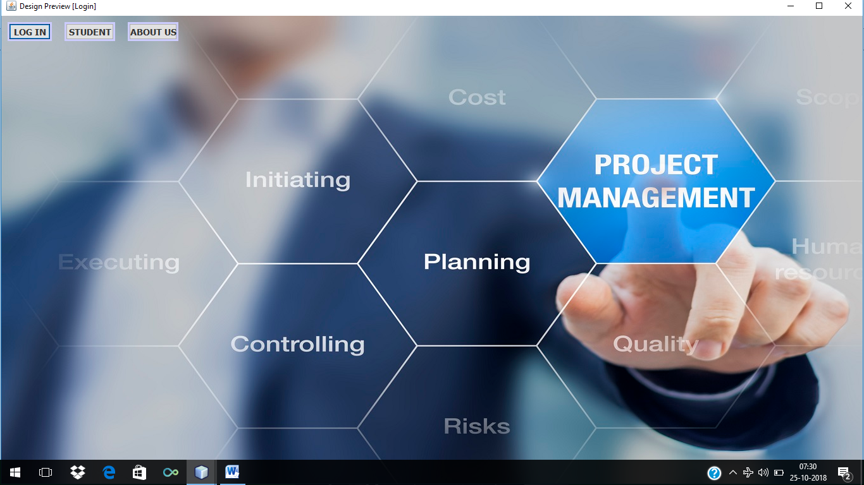

**ADMIN LOGIN-**

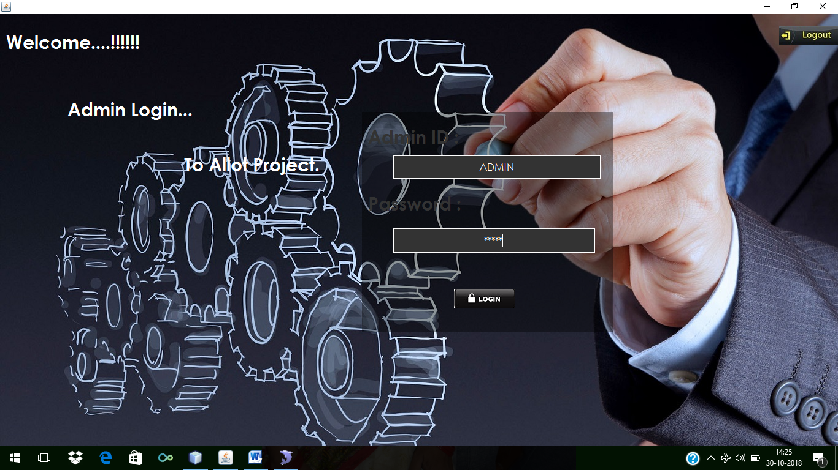

**LOADING-**

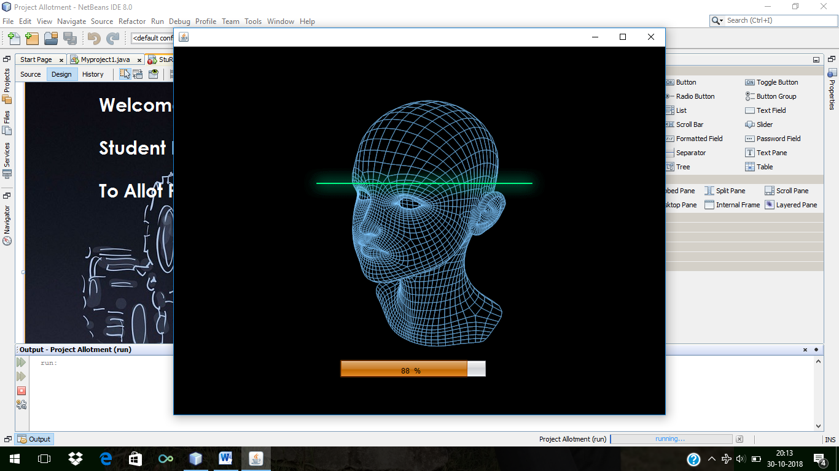

**MAIN WINDOW-**

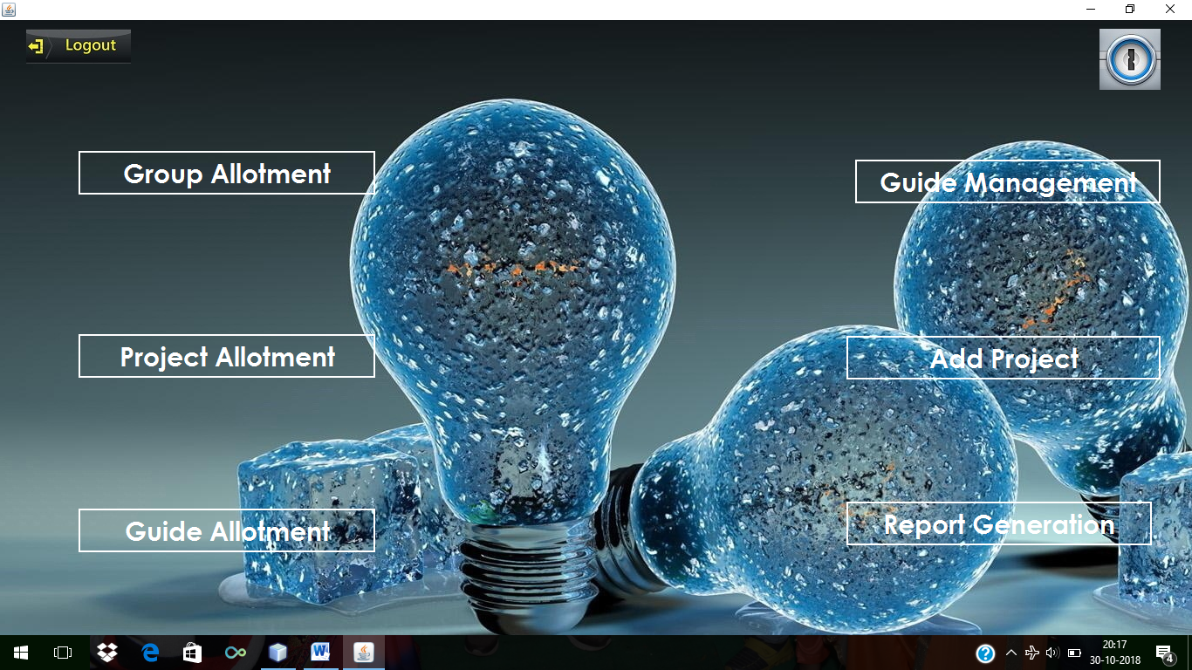

**GROUP ALLOTMENT-**

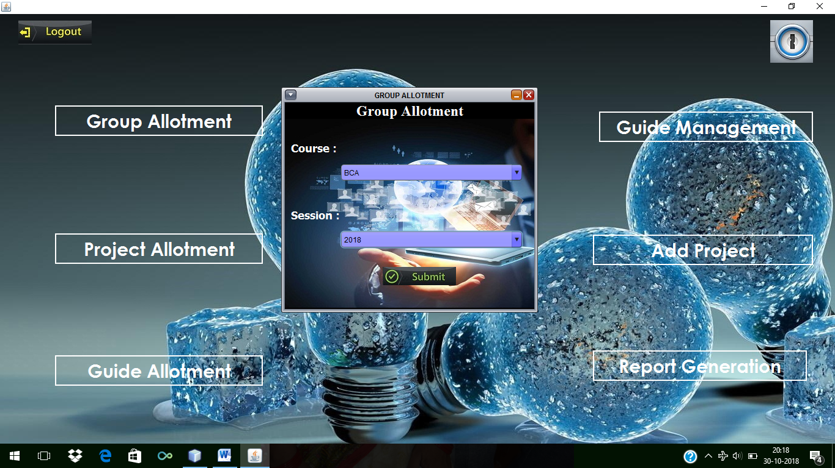

**STUDENTS LIST-**

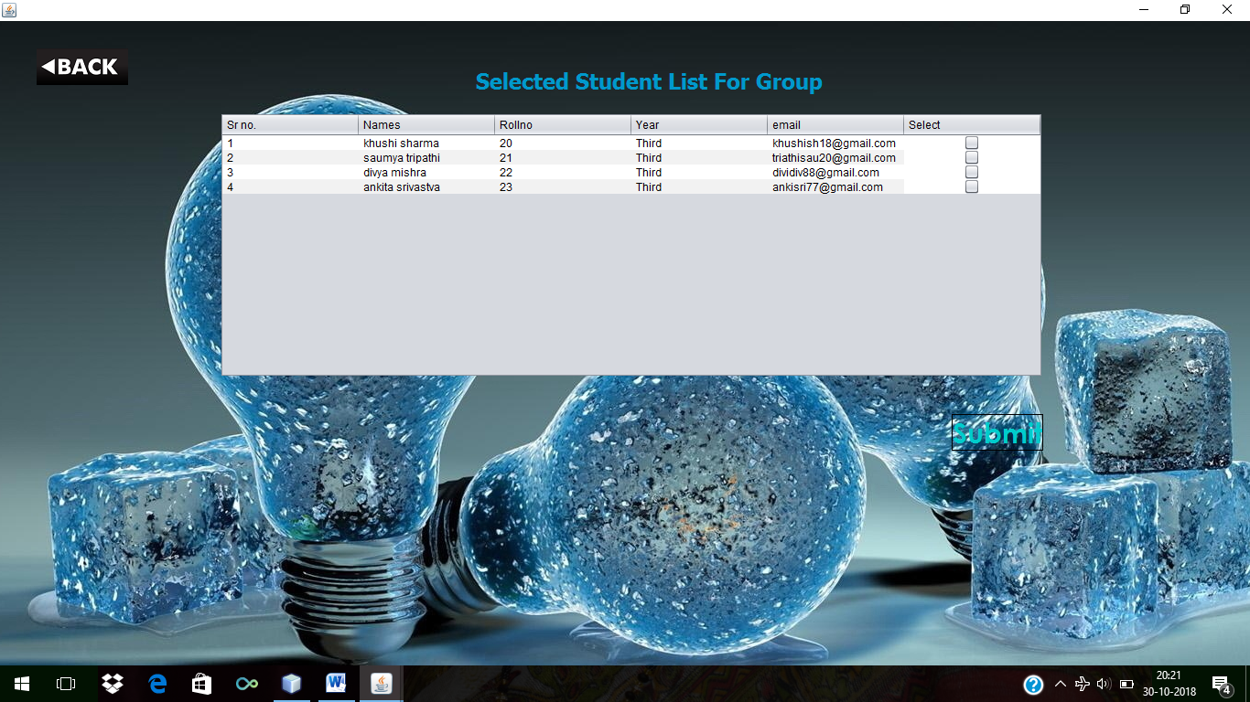

**PROJECT PLANNER-**

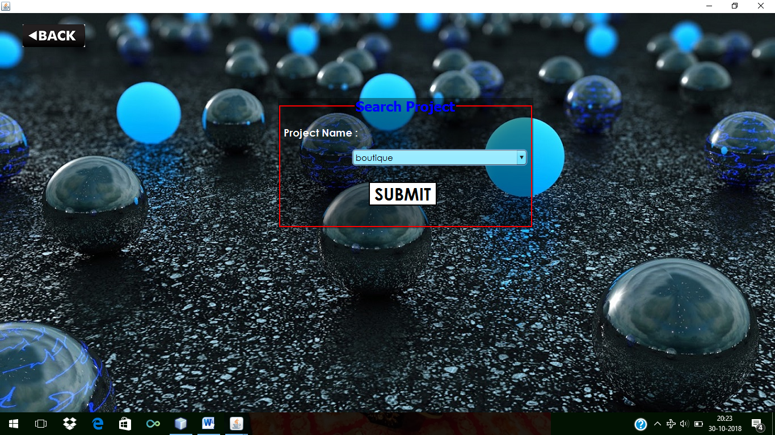

**PROJECT LIST-**

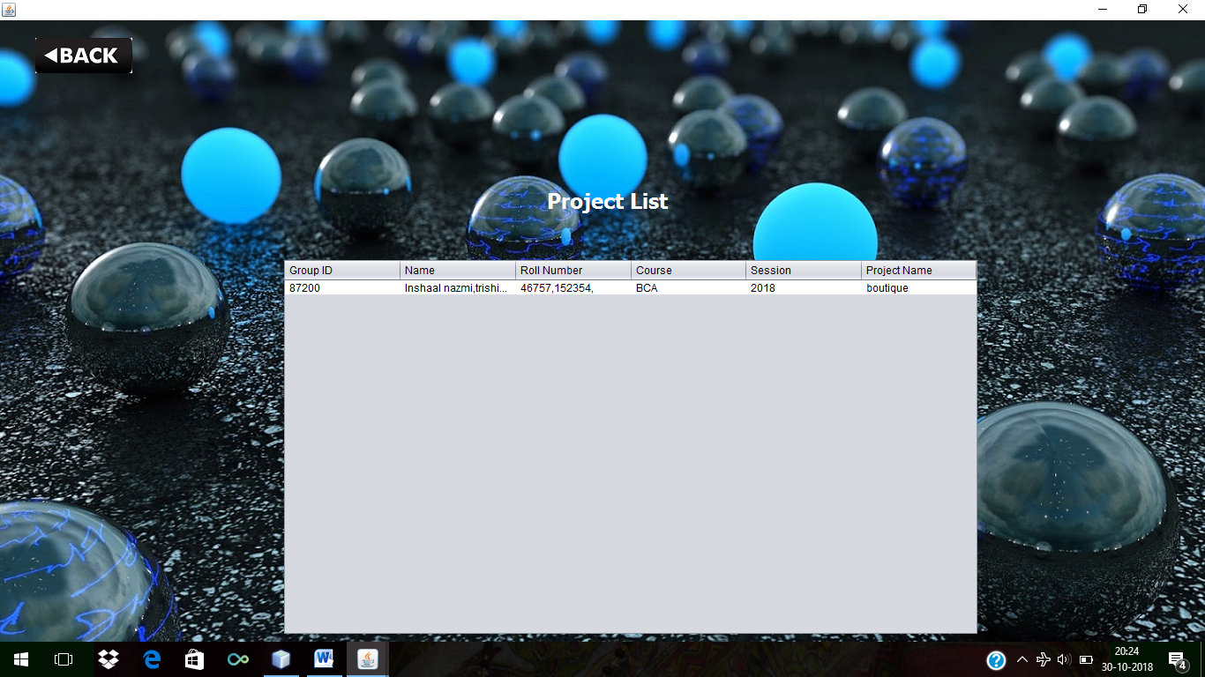

**GUIDE ALLOTMENT-**

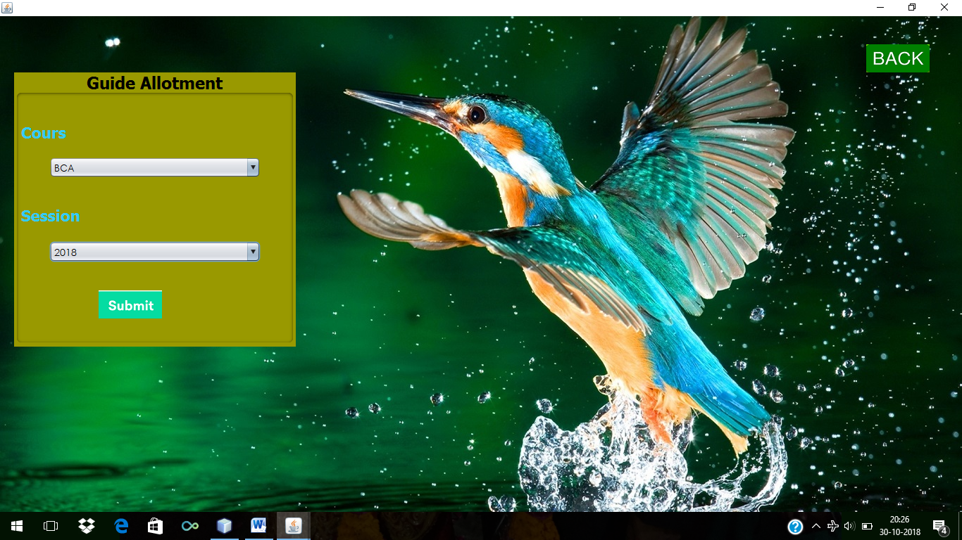

**GUIDE LIST-**

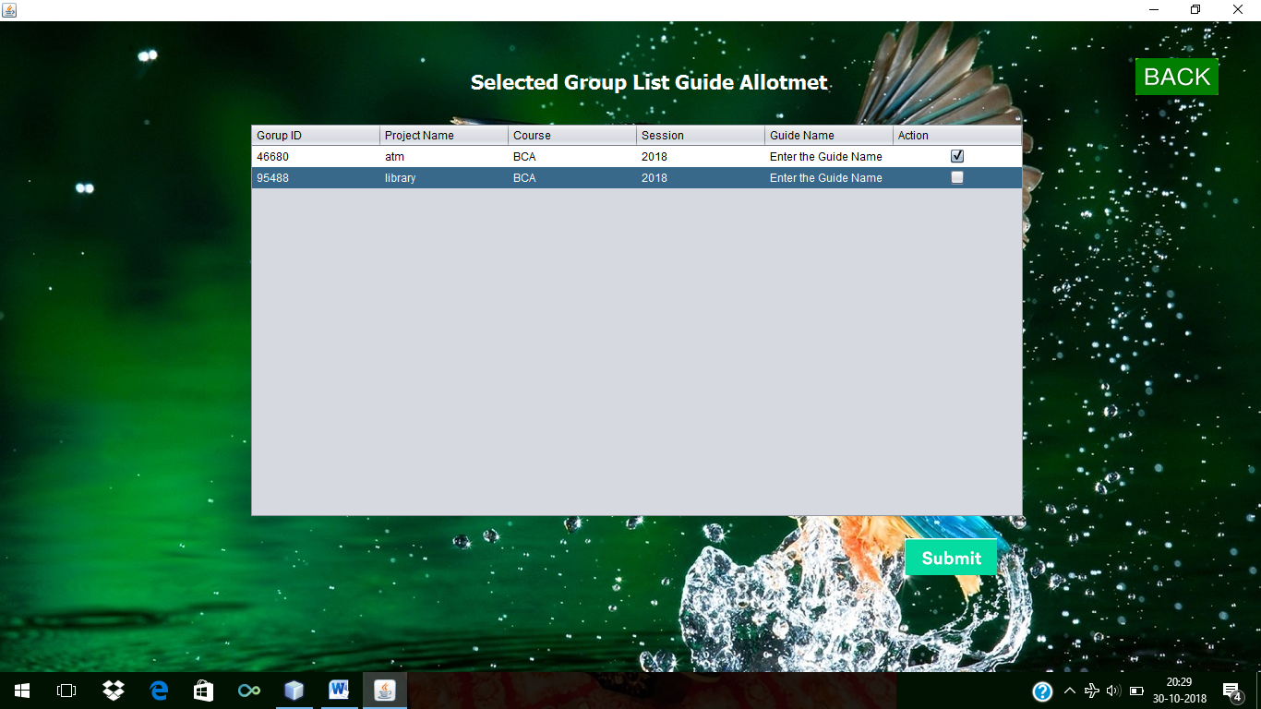

**GUIDE MANAGEMENT-**

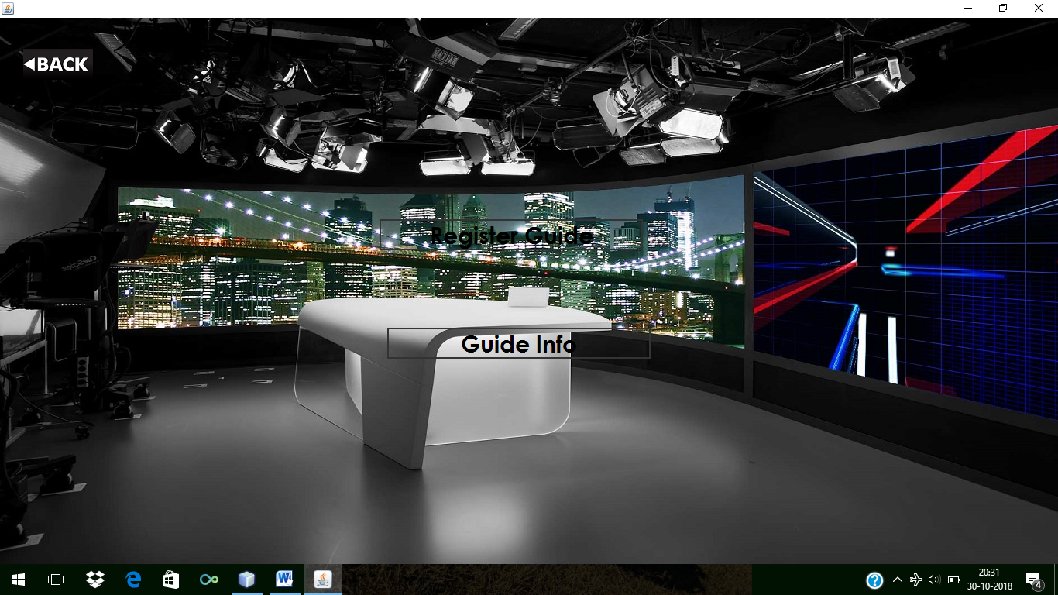

**FACULTY LIST-**

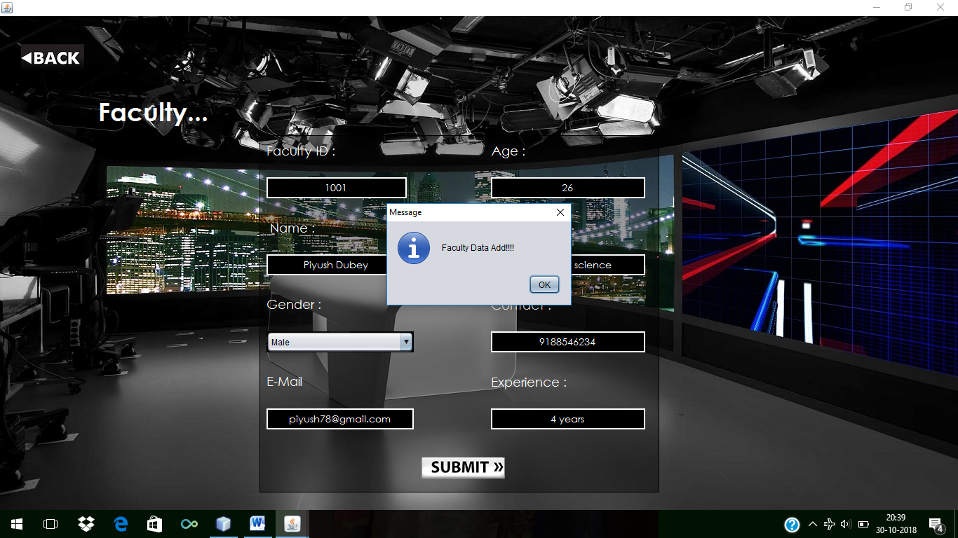

**GUIDE INFO-**

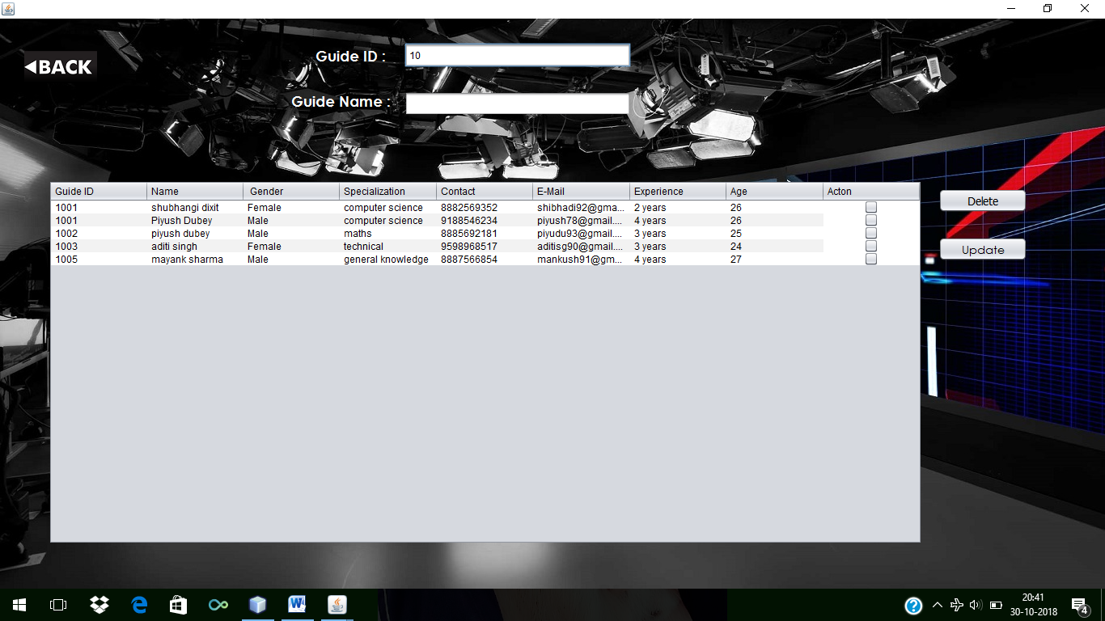

**ADD PROJECT-**

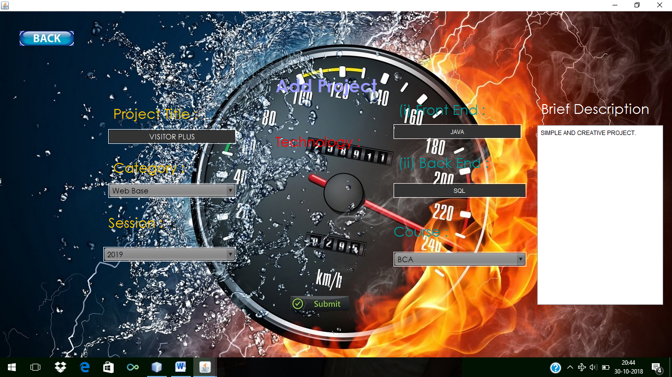

**REPORT GENERATION-**

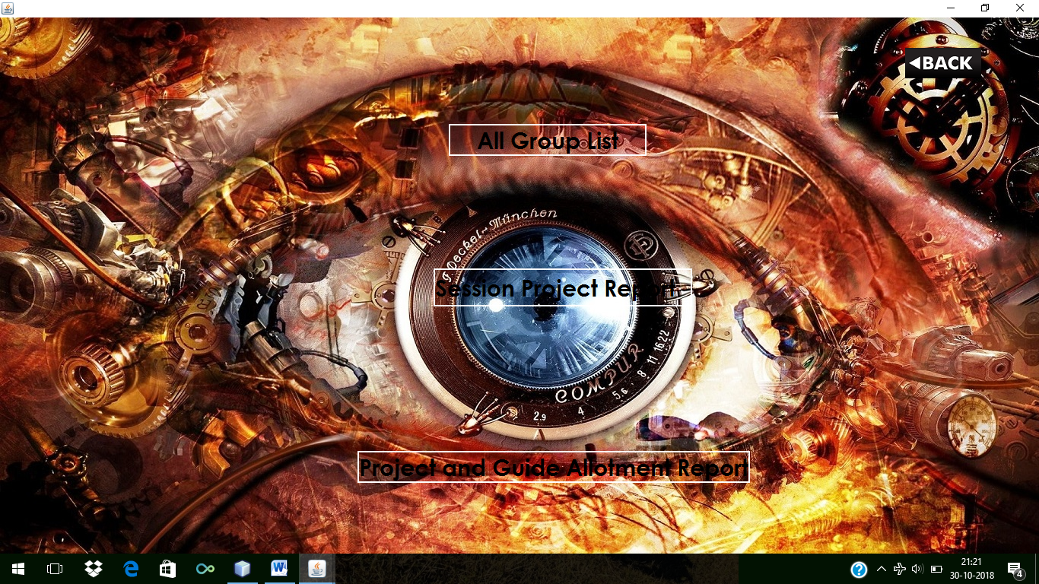

**SESSION PROJECT REPORT-**

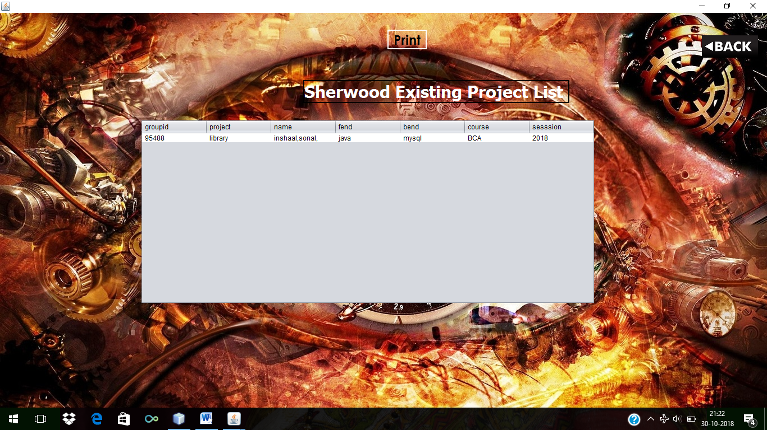

**PROJECT AND GUIDE ALLOTMENT REPORT-**



**STUDENTS REGISTRATION-**

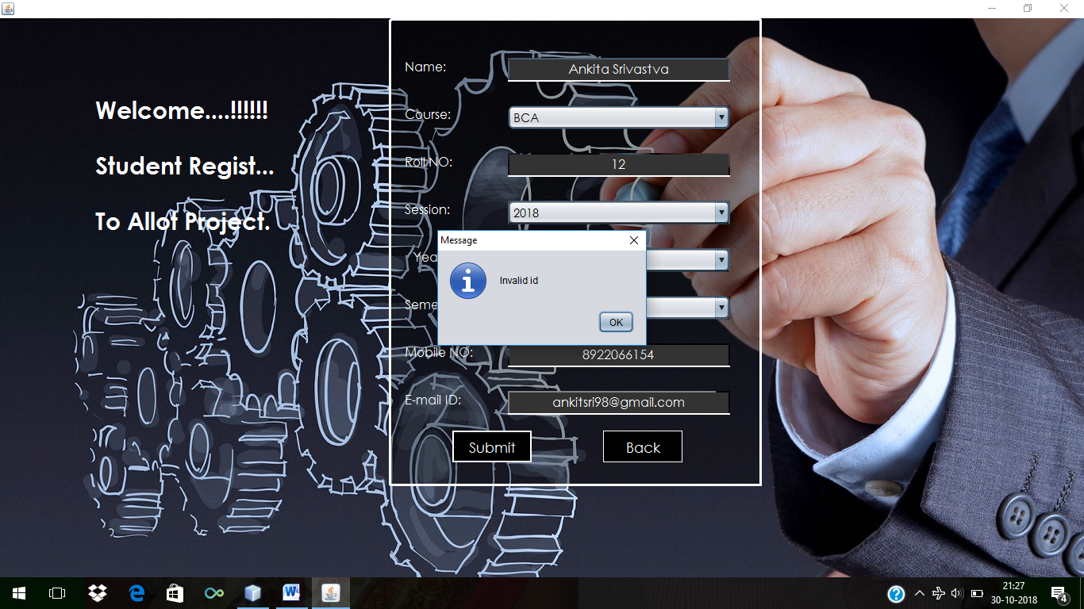

**6.TESTING**

**6.TESTING**

**System Testing: -**

Black box testing method was used for system testing. The black box testing usually demonstrates that software functions are operational; that the input is properly accepted and the output is correctly produced; and that integrity of external information (databases) is maintained.

**Why testing is done**

* Testing is the process of running a system with the intention of finding errors.
* Testing enhances the integrity of a system by detecting deviations in design and errors in the system.
* Testing aims at detecting error-prone areas. This helps in the prevention of errors in a system.
* Testing also add value to the product by confirming to the user requirements.

**Causes of Errors**

The most common causes of errors in a software system are:

* **Communication gap between the developer and the business decision** **maker:** A communication gap between the developer and the business decision maker is normally due to subtle differences between them. The differences can be classified into five broad areas: Thought process, Background and Experience, Interest, Priorities, Language.
* **Time provided to a developer to complete the project:** A common source of errors in projects comes from time constraints in delivering a product. To keep to the schedule, features can be cut. To keep the features, the schedule can be slipped. Failing to adjust the feature set or schedule when problems are discovered can lead to rushed work and flawed systems.
* **Over Commitment by the developer:** High enthusiasm can lead to over commitment by the developer. In these situations, developers are usually unable to adhere to deadlines or quality due to lack of resources or required skills on

the team.

* **Insufficient testing and quality control:** Insufficient testing is also a major source of breakdown of e-commerce systems during operations, as testing must be done during all phases of development.
* **Inadequate requirements gathering:**  A short time to market results in developers starting work on the Web site development without truly understanding the business and technical requirements. Also, developers may create client-side scripts using language that may not work on some client browsers.
* **Keeping pace with the fast changing Technology:** New technologies are constantly introduced. There may not be adequate time to develop expertise in the new technologies. This is a problem for two reasons. First, the technology may not be properly implemented. Second, the technology may not integrate well with the existing environment.

**Testing Principles**

* To discover as yet undiscovered errors.
* All tests should be traceable to customer’s requirement.
* Tests should be planned long before the testing actually begins.
* Testing should begin “in the small” & progress towards “testing in the large”.
* Exhaustive Testing is not possible.
* To be most effective training should be conducted by an Independent Third Party

**Testing Objectives**

* Testing is a process of executing a program with the intent of finding errors.
* A good test case is one that has a high probability of finding an as yet undiscovered error.
* A successful test is one that uncovers an as yet undiscovered error.

**Kinds of Testing:**

**Black Box Testing- Not** based on any knowledge of internal designs or code. Tests are based on requirements and functionality.

**White Box Testing-** Based on the knowledge of the internal logic of an application’s code. Tests are based on coverage of code statements, branches, paths and statements.

**Unit Testing-** The most ‘micro’ scale of testing; to test particular functions and code modules. Typically done by the programmer and not by the testers, as it requires detailed knowledge of the internal program design and code. Not always easily done unless the application has a well-designed architecture with tight code; may require developing test driver modules or test harnesses.

**Integration Testing-** Testing of combined parts of an application to determine if they function together correctly. The ‘parts’ can be code modules, individual applications, client and server applications on a network, etc. This type of testing is especially relevant to client/ server and distributed systems.

**Functional Testing-** Black-box type testing geared to functional requirements of an application; testers should do this type of testing. This doesn’t mean that the programmers shouldn’t check that their code works before releasing it.

**Regression Testing-** Re-testing after fixes or modifications of the software or its environment. It is difficult to determine how much re testing is needed, especially near the end of the development cycle. Automated testing tools can be especially useful for this type of testing.

**Acceptance Testing-** Final testing based on the specifications of the end user or customer or based on use by end-users/ customers over some limited period of time.

**User Acceptance Testing-** Determining if software is satisfactory to an end user customer

**Testing Technique Used:**

We will continuously test our project to insure that it is fully functional. In order to perform testing test cases are designed with the intent of finding the errors in the project and help in removing those errors. Testing begins at the module level and is conducted systematically. It is generally conducted by independent test groups or third party.

Testing is done in our project Online Restaurent Automation System with help of black box testing that exercise all the functional requirement of the project test cases are designed using this approaches by providing set of input conditions to get the expected output.

**Test Cases Designed**

**TEST CASES FOR CLIENT**

|  |  |  |  |
| --- | --- | --- | --- |
| **TEST CASE ID** | **INPUT** | **EXPECTED OUTPUT** | **ACTUAL OUTPUT** |
| 1 | Password and key combination | Start | Operation started |
| 2 | No Input | Alert Message | Select a valid configuration setting |

**TEST CASES FOR SERVER**

|  |  |  |  |
| --- | --- | --- | --- |
| **TEST CASE ID** | **INPUT** | **EXPECTED OUTPUT** | **ACTUAL OUTPUT** |
| 1 | 127.0.0.1 | Connection establish | Client Connected |
| 2 | Get Status | Alert Box | If no client selected “alert box” is displayed |
| 3 | Choose Path | Transfer files to valid path | Files transferred |

**7.Implementation**

**Implementation**

**Implementation of Security-**

Security is an important issue for modern IT system. System administrator and security administrator are responsible for safeguard’s organization data and computing infrastructure.

**Password Encryption:**

Whatever security measures taken, in any case if anyone with destructive or malicious mind gets access to the database he can temper the critical data. To restrict it we’ve used encrypting algorithm facilitated to us by Microsoft ASP.Net .

Two algorithms’ are there-

SHA1- It takes the password and encrypt it in a string of 40 characters.

MD5- It takes the password and encrypt it in a string of 32 characters.

The beauty of these Algorithms are that whatever be the length of password the length of converted string remains same.

However a question arise here that if this thing is that good then why didn’t we used it for storing each and every data????

The answer lies in the fact that not all data are needed to be encrypted as long as we keep the critical data(like password encrypted and safe). It will only increase the load on server and network with no additional advantage. So we’ve not used this encryption Algorithm on all data blindly.

We have implemented different approach related to security issue for our project “VisitorPlus”

**System Implementation**

During the implementation stage the system in physically created. Necessary programs are coded, debugged and documented. A new hardware is selected, ordered and installed.

**System Specification**

Every computer system consists of three major elements.

1. The Hardware
2. Application software such as visual studio
3. Operating system

For successful operation of the package following must be kept in mind:

Too many packages should not be used, as very few systems may have all those packages installed due to memory problem. Thus, the compatibility of the system development will get reduced.

**8.FUTURE SCOPE**

**Future Scope of the Project:**

* In a nutshell, it can be summarized that the future scope of the project circles around maintaining information regarding:
* We can add printer in future.
* We can give more advance software for Project Planner including more facilities
* We will host the platform on servers to make it accessible worldwide
* Integrate multiple load balancers to distribute the loads of the system
* Create the master and slave database structure to reduce the overload of the database queries
* Implement the backup mechanism for taking backup of codebase and database on regular basis on different servers

We have left all the options open so that if there is any other future requirement in the system by the user for the enhancement of the system then it is possible to implement them. In the last we would like to thanks all the persons involved in the development of the system directly or indirectly. We hope that the project will serve its purpose for which it is develop there by underlining success of process.

**9.LIMITATIOS**

**Limitation of Project on Project Planner**

Although I have put my best efforts to make the software flexible, easy to operate but limitations cannot be ruled out even by me. Though the software presents a broad range of options to its users some intricate options could not be covered into it; partly because of logistic and partly due to lack of sophistication. Paucity of time was also major constraint, thus it was not possible to make the software foolproof and dynamic. Lack of time also compelled me to ignore some part such as storing old result of the candidate etc.

Considerable efforts have made the software easy to operate even for the people not related to the field of computers but it is acknowledged that a layman may find it a bit problematic at the first instance. The user is provided help at each step for his convenience in working with the software.

**List of limitations which are available in the Project Planner:**

Excel export has not been developed for student, List due to some criticality.

The transactions are executed in off-line mode, hence on-line data for Customer, Editing capture and modification is not possible.

Off-line reports of City, messages, and Customer cannot be generated due to batch mode execution.

**10.CONCLUSION**

**CONCLUSION**

This section discuses the result of work done in this project and also mentions the future scope improvement

The software will be developed by implementing the concept of modularity which in turn reduces the complexity involved in maintaining it. The administrator should have a sound technical knowledge about maintaining the software and further enhancements will be undertaken by the developer.

The application is portable which ensure its adaptability for use on different computer terminals with different operating system and standards.

The factors guarantee the software’s availability includes proper termination and correct input details. Also the resources used for the project development are Microsoft certified which speaks of its high quality standards.

Hence we may conclude that the application system being developed helps a great deal in modifying the computerized **Project Allotmnet.**

**11.REFRENCES**

**References**

The following books were referred during the analysis and execution phase of the project

**Common Language Runtime**

By Steven Pratschner

**SOFTWARE ENGINEERING**

By Roger S. Pressman

**UNIFIED MODELING LANGUAGE**

By Gradi Booch, Ivar Jacobson,

James Rambaugh

**COMPLETE REFERENCE .NET**

By David S Platt

**MSDN 2003**

By Microsoft

**IMAGES**

Google Search

Msn Search

Bing Search

**HTML PUBLISHING BIBL**

- Alan Simpson.

**C# 2008**

Andrew Troelson

**WEBSITES:**

[www.google.com](http://www.google.com)

[www.bing.com](http://www.bing.com)

[www.msn.com](http://www.msn.com)

[www.wikipedia.com](http://www.wikipedia.com)

[www.imagegallery.com](http://www.imagegallery.com)

[www.sql.com](http://www.sql.com)’

[www.learnjava.com](http://www.learnjava.com)